**Programming Fundamentals**

**Lab Report**

**Lab02**



|  |  |
| --- | --- |
| Group Members Name & Reg #: | **Muhammad Haris Irfan**  **(FA18-BCE-090)** |
|  |  |
| Class | Programming Fundamentals CSC103 (**BCE-2B**) |
| Instructor’s Name | Dilshad Sabir |

**In Lab Tasks**

**Question no: 1**

Following figure shows a pattern of squares generated for different input values of N (for N=0 to N=5). Develop a general algorithm to fill in the grid for any input N. Use the 4 step process that was discussed in the class (and is given below for reference)

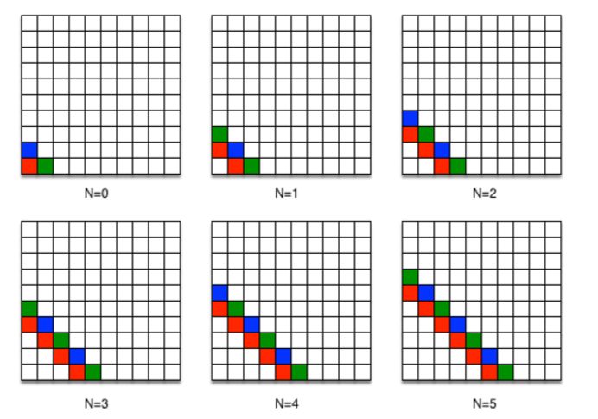

Write an Algorithm for the following?

**Solution:**

**Algorithm for any N:**

**Step 1:**  Let N be any number.

**Step 2:** Take two variables X and Y

**Step 3:** Let x=0.

**Step 4:** Let y=x.

**Step 5:** If (X+Y) is equal to N, then put a RED Square in (X, Y)

**Step 6:** Or If (X+Y) is equal to N+1 and Y is not a multiple of 2 (i.e Y%2 != 0), then put a BLUE Square at (X,Y)

**Step 7:** Or If (X+Y) is equal to N+1 and Y is a multiple of 2 (i.e Y%2==0), then put a GREEN Square at (X, Y)

**Step 8:** Otherwise don’t put any color in (X, Y)

**Step 9:** if Y is less then N+1, then add 1 in Y

**Step 10**: Otherwise add 1 in X and Update the value of Y to 0

**Step 11**: Repeat from Step 5 till X is equal to N+1.

**Step 12:** Terminate after X is equal to N+1 and Y= 0

**Testing our Algorithm:**

Now we will test the above Algorithm for N =2 and verify our algorithm.

* Given N=2
* X=0,
* Y=0, as Y=X

Now

1. (0+0) is not equal to N

(0+0) is not equal to N+1

Hence no condition is fulfilled, so we will not put any color in (0,0)

Now as Y is less then N+1 (0<2)

We will update Y=0+1

Y=1

1. Now X=0 and Y=1

(0+1) is not equal to N

(0+1) is not equal to N+1

Hence no condition is fulfilled, so we will not put any color in (0,1)

Now as Y is less then N+1 (0<2)

We will update Y=1+1

Y=2

**3)** Now X=0 and Y=2

(0+2) is equal to N, hence the condition is fulfilled so we will Put Red Color in (0,2)

Now as Y is less then N+1 (0<2)

We will update Y=2+1

Y=3

**4)** Now X=0 and Y=3

(0+3) is equal to N+1 and Y is not a multiple of 2,

Hence the condition is fulfilled, so we will put any BLUE color in (0,3)

Now as Y is not less then N+1 (3<2)

Then we will Add 1 in X and Update Y=0

X=1

Y=0

**5)** Now X=1 and Y=0

(1+0) is not equal to N

(1+0) is not equal to N+1

Hence no condition is fulfilled, so we will not put any color in (1,0)

Now as Y is less then N+1 (0<2)

We will update Y=0+1

Y=1

**6)** Now X=1 and Y=1

(1+1) is equal to N

Hence the condition is fulfilled, so we will put Red Color at (1,1)

Now as Y is less then N+1 (1<2)

We will update Y=1+1

Y=2

**7)** Now X=1 and Y=2

(1+2) is equal to N+1 and Y is a Multiple of 2,

Hence the condition is fulfilled, so we will not put Green color at (1,2)

Now as Y is not less then N+1 (2<2)

We will add 1 in X and update Y=0

X=2

Y=0

**8)** Now X=2 and Y=0

(2+0) is not equal to N

Hence the condition is fulfilled, so we will put Red any color in (2,0)

Now as Y is less then N+1 (0<2)

We will update Y=0+1

Y=1

**9)** Now X=2 and Y=1

(2+1) is not equal to N+1 and Y is not a multiple of 2

Hence the condition is fulfilled, so we will put Blue any color in (2,1)

Now as Y is less then N+1 (1<2)

We will update Y=1+1

Y=2

**10)** Now X=2 and Y=2

(2+2) is not equal to N

(2+2) is not equal to N+1

Hence no condition is fulfilled, so we will not put any color in (2,2)

Now as Y is not less then N+1 (2<2)

We will update X=2+1 and Y=0

X=3

**11)** Now X=3 and Y=0

(3+0) is equal to N+1

Hence the condition is fulfilled, so we will put Blue any color in (3,0)

Now as X= N+1 and Y=0, the Program will terminate.

We got the same pattern as the above pattern; hence our Algorithm is verified as correct, I have also checked the above algorithm for N=6 and it works fine.

_____________________________

**QUESTION NO:2**

Write a C program for following piecewise function. Program must take input from user and calculate and print the function result on screen.

$$f[n]=\left\{\begin{aligned}-n-4, & n<3 \\ n^{2}-7, & 3≤n≤10 \\ \frac{120}{n} +n, n>10 \\ \\ where n is an integer variable\end{aligned}\right.$$

Solution:

I am attaching my code below, for this program, I used If/else Statements in my code, I took input n from the user and if (n<3) a certain function was performed, if n was greater then equal to 3 and less then equal to 10 then another function was performed, for value of n greater then 10 a specific function was performed.

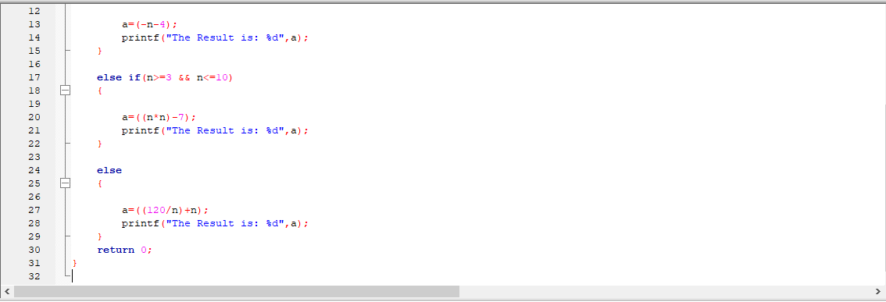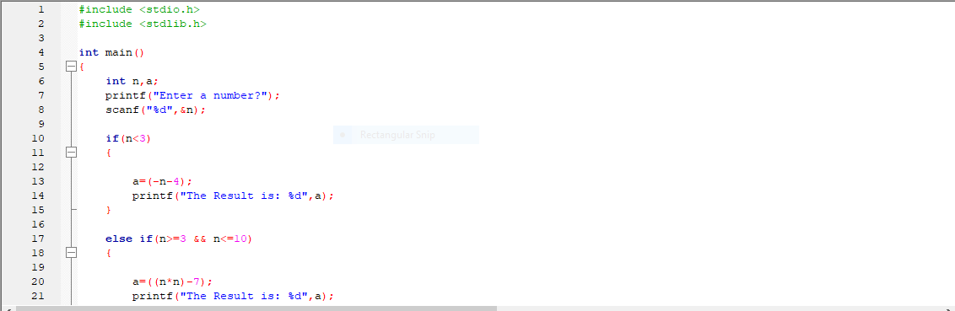

3 tested values from Each function is Attached below:

For n=2

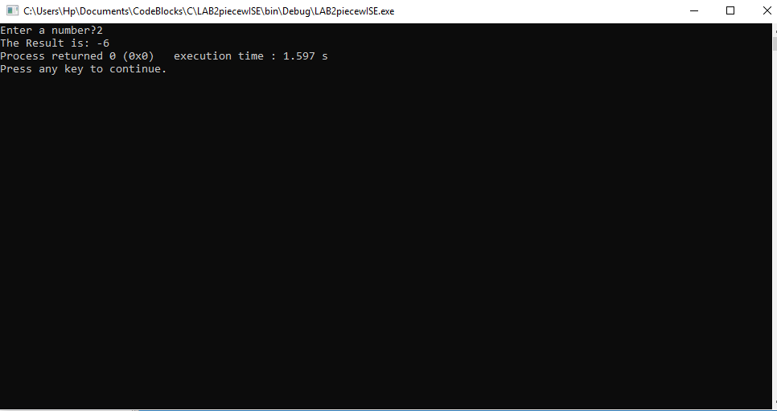

For n=4

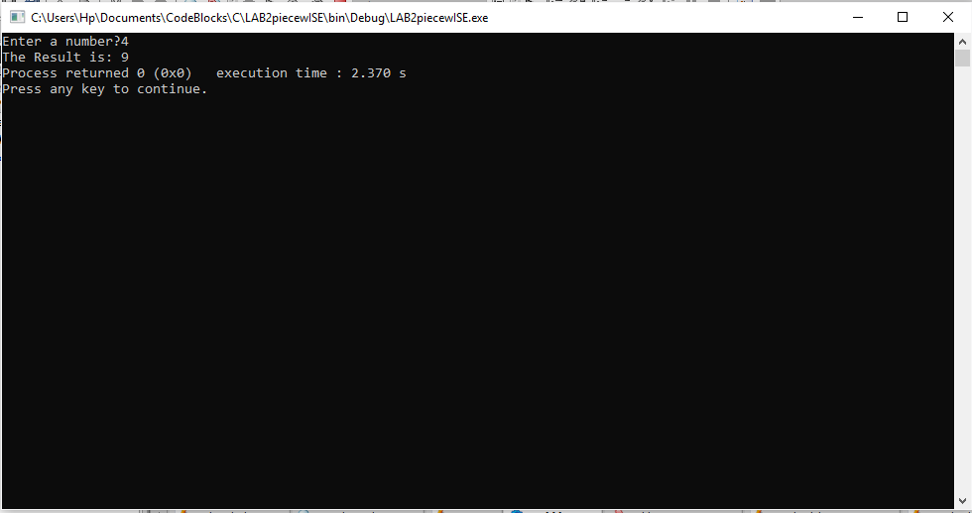

For n=14

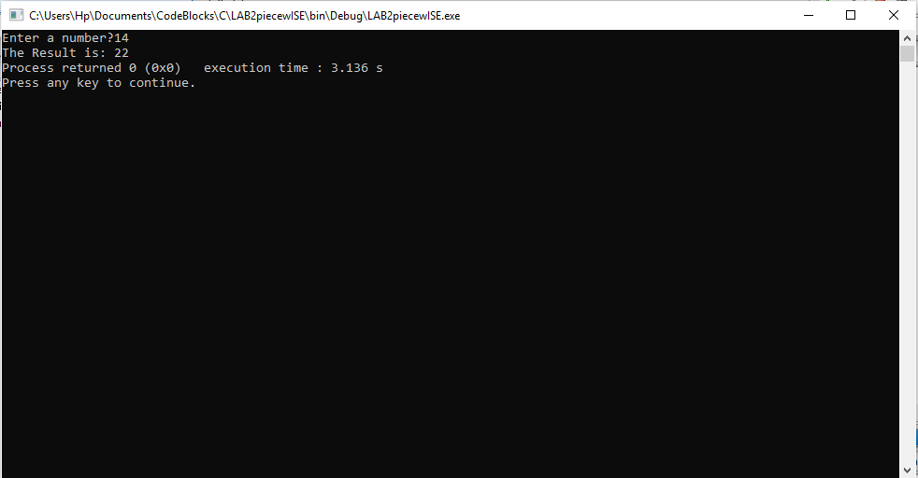

POST LAB

Question:

Write a program that takes integer input from user and tells (displays on the output console screen) whether it is even or odd.

Solution:

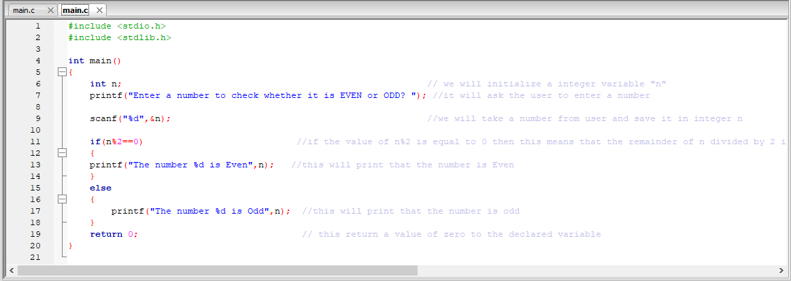I am attaching my code below for this program as well, I used if/else statement with MOD operator in this program, my program takes a certain value as input from the user and then checks if the value is a multiple of 2, if it is a multiple of 2 then Even is printed on the console else it prints that the number is Odd, for this I used MOD operator which check if N divided by two has a remainder of 0 or not (N%2==0) if N divided by zero gives 0 as remainder then the Integer N is said to be Even otherwise Odd.

Below I’m attaching the output for one even and one odd value to verify the program,

For Input Value: 66

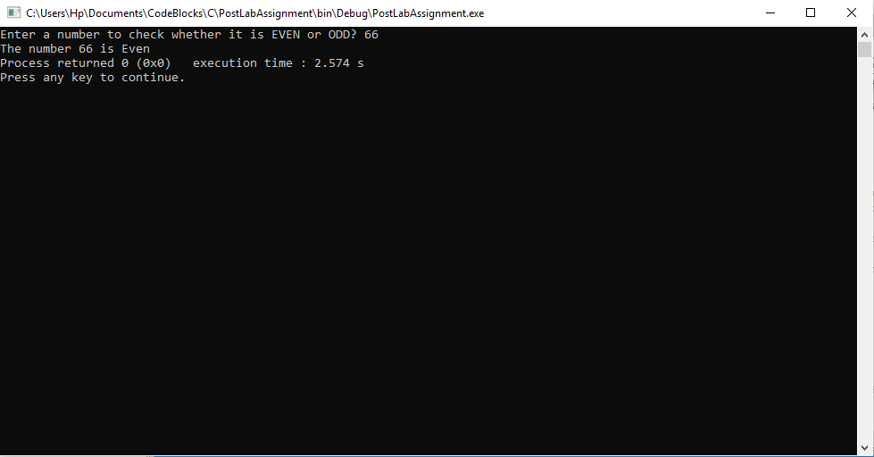

For input Value: 67

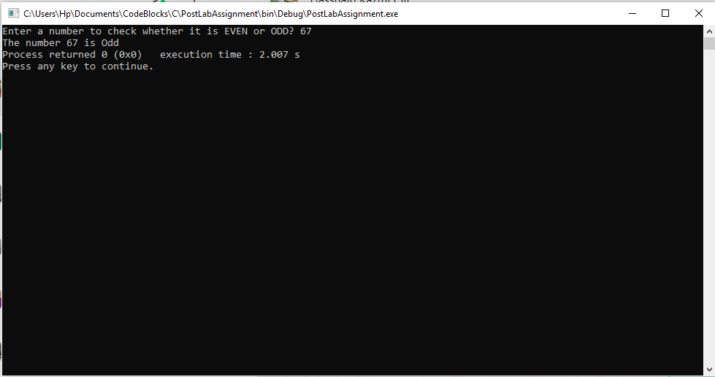

Hence, The Output further verifies that the program is correct, I have also added comments in code and tried to explain it line by line.

______THE END________